PROJECT REPORT ON

**“Jagur car collection Webpage”**

Submitted By:

BRIJESH KUMAR KUSHWAHA

1KN20CS006

# Under The Guidance Of:

# AQMENZ Automation Pvt. Ltd

# Ocotber, 2023



**Bengaluru-560064, India**

# Certificate

This is to certify that Brijesh Kumar Kushwaha have successfully completed the project titled **“Jagur car collection Webpage”** at AQMENZ Automation Pvt. Ltd under my supervision and guidance of AQMENZ Automation Pvt. Ltd

# 

# Acknowledgement

The successful completion of the "Jaguar Car Collection Web Page" project is the culmination of the collective efforts, dedication, and support of many individuals and organizations who have played an integral role in its realization.

First and foremost, we extend our heartfelt gratitude to the Jaguar team, whose unwavering commitment to excellence and innovation has been a continuous source of inspiration throughout this project. Their support, cooperation, and insights have been invaluable in creating a web page that does justice to the iconic Jaguar brand.

We would like to express our deep appreciation to our project advisors and mentors, AQMENZ Automation Pvt. Ltd.whose guidance and expertise have been pivotal in shaping our vision and refining our project objectives. Their constructive feedback and unwavering encouragement have been instrumental in steering us toward success.

Our project's journey has been marked by the dedication and hard work of our team members, [Team Member Names], who brought their unique skills and perspectives to the table, ensuring that every aspect of the web page met the highest standards of quality and creativity. Their collaboration and tireless efforts have been the driving force behind this project.

We also acknowledge the critical role played by our technical partners, [Partner Names], whose contributions in terms of technology, resources, and expertise have been indispensable in achieving our project goals.

Furthermore, we extend our appreciation to our institution, [Institution Name], for its support and the resources provided to us throughout the project's lifecycle.

Lastly, we are grateful to the Jaguar enthusiasts and the wider online community who we hope will find value, enjoyment, and inspiration in the "Jaguar Car Collection Web Page." Their engagement and feedback will be an ongoing source of motivation for us.

# Abstract

**The "Jaguar Car Collection Web Page" project is a testament to the fusion of technology and automotive excellence, offering a captivating and informative platform for Jaguar enthusiasts and prospective buyers. By employing meticulous HTML structuring and creative CSS styling, the project aims to showcase the rich heritage and contemporary brilliance of Jaguar's vehicle lineup. This web page serves as a comprehensive resource, featuring a virtual showroom for 3D exploration, an educational hub for in-depth knowledge about Jaguar's engineering and history, a comparison tool for assessing specifications, a reservation system for test drives and bookings, a community hub for sharing experiences, a car configurator for personalized customization, and a news section for staying updated on the latest from Jaguar.With the inclusion of interactive tours, user-generated content, and user reviews, the web page fosters community engagement and user interaction. Ultimately, the project aspires to provide a seamless and enjoyable experience for users across all devices while promoting the luxury, style, and cutting-edge design that define the Jaguar brand.**

# CONTENTS

|  |  |  |
| --- | --- | --- |
| **No.** | **Topics** | **Page** |
| 1. | Introduction | 6 |
| 2. | Software Requirements And Specifications | 7 |
| 3. | Screenshots | 9 |
| 4. | Conclusion | 11 |

* 1. **INTRODUCTON**

The "Jaguar Car Collection Web Page" project embarks on a journey into the realm of luxury, innovation, and the timeless allure of Jaguar's automotive craftsmanship. In an age where digital representation and user experience are paramount, we have embarked on a mission to craft a virtual showcase that mirrors Jaguar's illustrious history while embracing the cutting-edge technologies of the digital age. Through meticulous HTML structuring and creative CSS styling, this project aspires to present a meticulously curated collection of Jaguar's iconic and contemporary vehicles, inviting enthusiasts, potential buyers, and curious visitors to explore and immerse themselves in the world of Jaguar.Jaguar, renowned for its emblematic blend of performance, style, and engineering excellence, has consistently been a symbol of automotive artistry. The "Jaguar Car Collection Web Page" is not just a website; it's an embodiment of this legacy, meticulously designed to captivate the senses and evoke the spirit of Jaguar.Our project objectives extend beyond the mere presentation of vehicles; they encompass the creation of a dynamic and interactive online platform that weaves together history, technology, user engagement, and community. It serves as a virtual showroom, an educational resource, a comparison tool, a reservation system, a community hub, a car configurator, a news source, and an arena for user-generated content. Through these facets, we aim to not only showcase Jaguar but to engage, educate, and inspire a global community of Jaguar enthusiasts.In this digital age, our project endeavors to ensure that users across all devices can seamlessly navigate, explore, and connect with the world of Jaguar. We aspire to provide a sophisticated and enjoyable browsing experience, honoring the elegance and excellence that are synonymous with the Jaguar brand.As we delve into the construction of this web page, we do so with unwavering dedication to capturing the essence of Jaguar and delivering an online experience that matches the craftsmanship and innovation Jaguar represents.Welcome to the "Jaguar Car Collection Web Page," where luxury, style, and cutting-edge automotive design meet the digital age.

Specific Requirements

The whole of this project work will be developed using the OMNeT++ simulator which uses the NED language for the purpose of the development of the network and the C++ language for the module definitions. So the specific requirements for this project work are :

* Microsoft Visual Studio Code.
* Windows XP or any compatible Operating Systems.
* Google chrome or any browser

As an end product the algorithm developed by us will be implemented in mobile or other embedded devices operating under a wireless and mobile atmosphere. In that scenario the whole internal working will be abstracted from the actual users of the product and it is of no importance for them to understand the specific requirements of the programs executing inside their devices.

## Performance Requirements

The algorithms developed are purely based on a wireless domain and will be implemented on embedded devices as an end product. So it is not our concern about the performance of the embedded devices which is rather a concern of the company who will be implementing this technology in their products. For the purpose of development the only performance requirements are related to the specific software requirements mentioned above and a system which is capable of smoothly running these above said softwares is good enough for the project members to work on the proposed algorithms.

# PROJECT PLAN

The "Jaguar Car Collection Web Page" project plan was meticulously designed to bring our vision to life and achieve the outlined objectives. We initiated the project with a comprehensive analysis of the scope, identifying the need for an engaging and informative online platform for Jaguar enthusiasts and prospective buyers. With a clear sense of purpose, we structured our project plan around several key phases and milestones.

The initial phase focused on research and conceptualization. We conducted in-depth research on Jaguar's history, models, and technological innovations, ensuring that we had a deep understanding of the brand's identity. Simultaneously, we conceptualized the features and functionalities that would best cater to our target audience while reflecting the brand's values.

The subsequent phase involved design and development. Our team of skilled designers and developers collaborated closely to bring the project to life. We established the website's structure using HTML and applied CSS styling to ensure an aesthetically pleasing and user-friendly interface. The development phase included creating the virtual showroom, educational resources, comparison tools, reservation systems, and interactive features that define the web page.

Quality assurance and testing were integral parts of our plan. We rigorously tested the web page to ensure compatibility across various devices and browsers, as well as responsiveness and overall performance. Any identified issues or glitches were promptly addressed to provide a seamless user experience.

As the project moved toward completion, we paid close attention to the content creation and data integration, ensuring that the website was populated with accurate and engaging information. User-generated content features were also integrated, allowing Jaguar enthusiasts to contribute their insights and experiences.

We set clear timelines and milestones, keeping a watchful eye on the project's progress throughout its development. Our project plan reflects our commitment to delivering a high-quality web page that resonates with the Jaguar community and enthusiasts.

The "Jaguar Car Collection Web Page" project plan is a testament to our dedication and passion for both the Jaguar brand and the digital realm. It has been a dynamic journey marked by creative ingenuity, technical expertise, and an unwavering commitment to excellence.

Screenshots:

1.

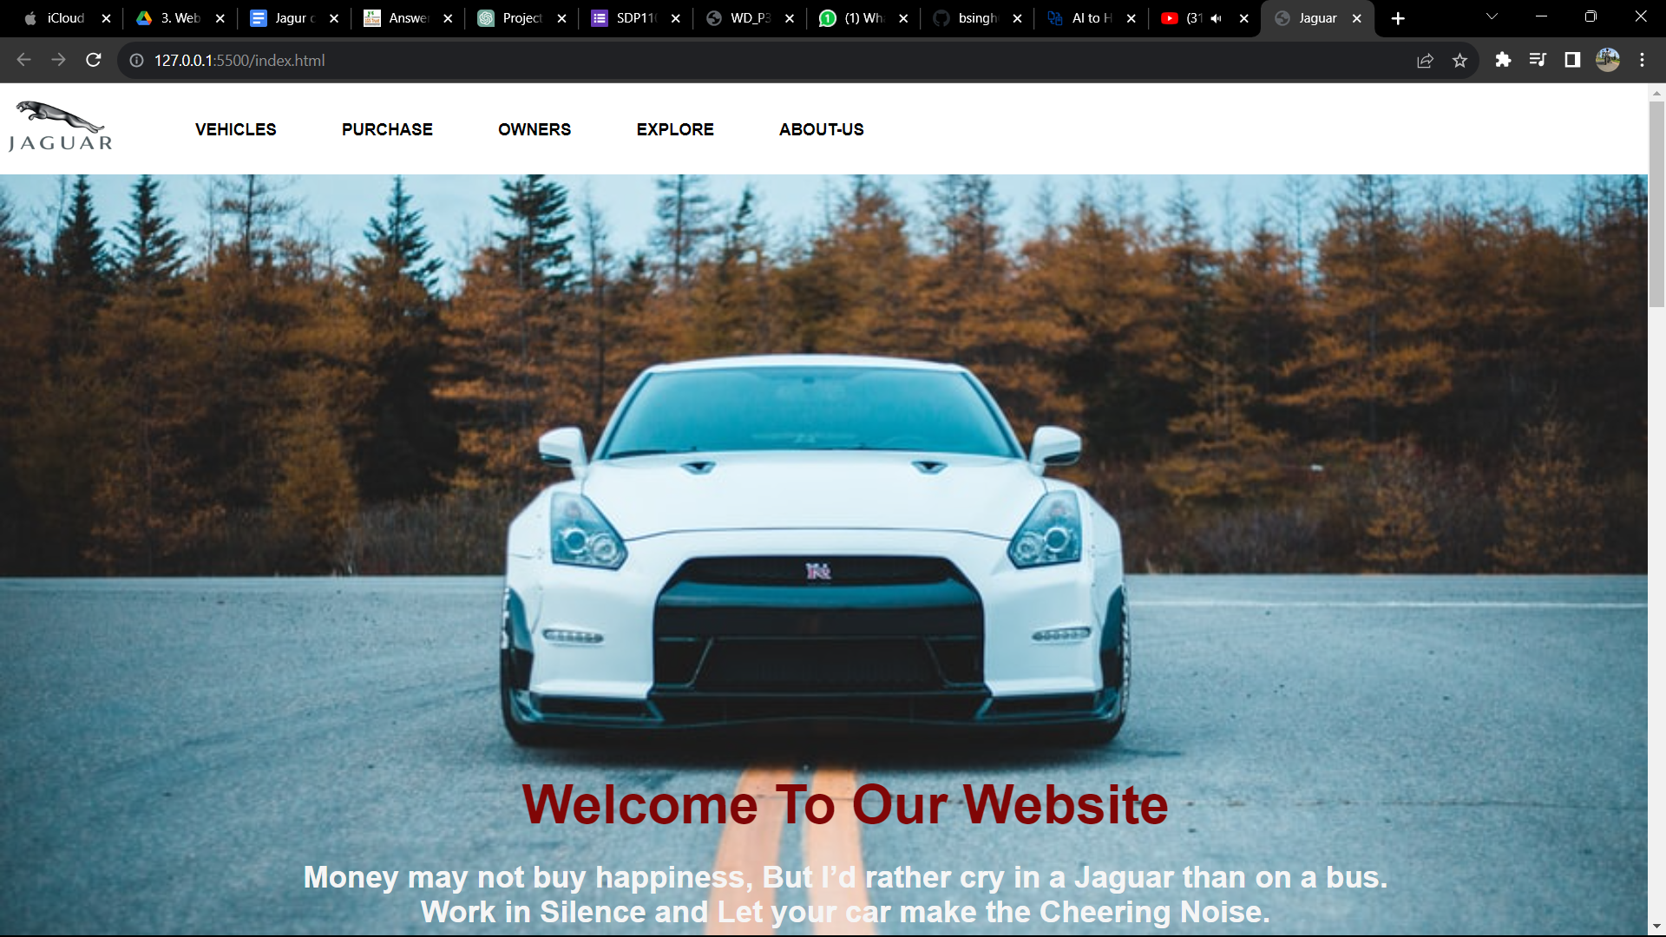

# 

# 2.

# 

# 3.

# 

# CONCLUSION

The "Jaguar Car Collection Web Page" project stands as a testament to the fusion of artistry, technology, and a profound passion for Jaguar's illustrious legacy. Throughout this project, our team has ardently endeavored to create an online platform that not only showcases Jaguar's rich heritage but also engages and educates a global community of enthusiasts and prospective buyers. As we draw the curtains on this project, we reflect on the milestones achieved and the enduring impact we aim to make in the digital realm.

The essence of the Jaguar brand, with its relentless pursuit of excellence, has been at the forefront of our design and development. From the inception of the project, our primary objective was to encapsulate the brand's elegance and innovation in a digital space. By crafting a virtual showroom, educational resource, comparison tool, reservation system, community hub, car configurator, and news source, we have striven to provide a comprehensive and immersive experience for users.

This project's success lies not just in the lines of code or the aesthetic appeal of the web page but in the potential it holds to connect people, to foster a sense of community among Jaguar enthusiasts, and to contribute to the brand's legacy. Our dedication to creating a responsive and user-friendly platform underscores our commitment to making the world of Jaguar accessible to all.

The "Jaguar Car Collection Web Page" is not just a digital presence; it is an embodiment of the spirit of Jaguar. It is an invitation to explore, learn, and share in the passion that drives Jaguar enthusiasts worldwide. As we part ways with this project, we do so with immense pride in what we have created, and with a resolute commitment to ensuring that the world of Jaguar remains an enduring source of inspiration in the digital age.

The road ahead is filled with opportunities for growth, engagement, and further refinement. We look forward to the continued evolution of the "Jaguar Car Collection Web Page" as it becomes a hub for Jaguar enthusiasts and an online showcase that resonates with the brand's core values. We extend our gratitude to all who have supported us in this endeavor, and we invite the world to explore the world of Jaguar through the lens of our web page.

This conclusion summarizes the achievements of the project and underscores its significance in connecting the Jaguar community while looking forward to future possibilities.